Wales National Travel Survey – Dress Rehearsal Analysis Report
Authors: Nick Waugh, Ella Gerlack, Shane Howe & Peter Cornick
Prepared for: Transport for Wales and The Welsh Government
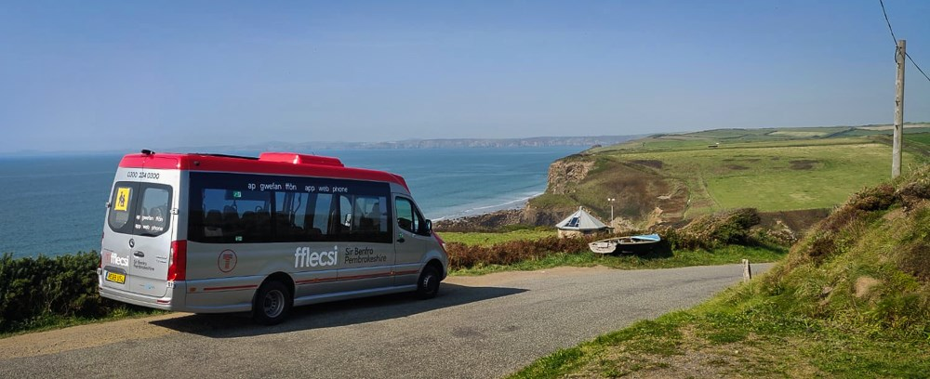
November 2024

We believe that social research has the power to make life better.
By really understanding the complexity of people’s lives and what they think about the issues that affect them, we give the public a powerful and influential role in shaping decisions and services that can make a difference to everyone. And as an independent, not for profit organisation we’re able to put all our time and energy into delivering social research that works for society. |  | National Centre  for Social Research  35 Northampton Square  London EC1V 0AX  020 7250 1866  www.natcen.ac.uk  A Company Limited by  Guarantee  Registered in England  No.4392418  A Charity registered in England  and Wales (1091768) and  Scotland (SC038454)  This project was carried out  in compliance with ISO20252  designbysoapbox.com


Contents

1. Introduction 7
1.1 Background to the Wales National Travel Survey 7
1.2 WNTS Dress Rehearsal 7
1.3 Sample selection 8
2. Quantitative findings 9
2.1 Descriptive statistics for the dress rehearsal 9
2.2 Questionnaire length 9
2.3 Consent to follow-up studies 10
2.4 Journey rate 11
2.5 Spread of days across the week 13
3. End-to-end CAPI process 16
3.1 The end-to-end CAPI process 16
3.2 Creation and allocation of the sample 16
3.3 Interviewer training 17
3.4 Fieldwork administration 18
3.5 Materials 22
3.6 Conducting the interview 23
4. End-to-end data processing 34
4.1 End-to-end data processing 34
4.2 Merging of data 34
4.3 Removal of empty variables 37
4.4 Data outputs 37
5. Testing the transfer of sample from mode-to-mode 39
5.1 Mixed-mode sample transfer 39
6. Testing the efficiency of the CATI element 41
6.1 The CATI element 41
6.2 Uptake and experience 41
6.3 Further implications 42
7. Weighting 43
7.1 Weighting the data for mainstage WNTS 43
8. Recommendations 44
Appendix A 48
Appendix B 49
Appendix C 50
Appendix D 51

- Introduction

Background to the Wales National Travel Survey
The Wales National Travel Survey (WNTS) is a web-first survey employing a combination of web, telephone, and face-to-face interviewing designed to measure travel attitudes and behaviours among residents of Wales.

The instrument consists of two components: (1) a questionnaire and (2) a 2-day travel diary, both of which are programmed using Blaise 5, a software suite developed by Statistics Netherlands for creating, managing, and deploying survey data collection instruments. As part of the survey development, two pilots took place in the second and third quarters of 2024.

Conducted between 3rd May 2024 and 2nd June 2024, the primary aims of Pilot 1 were to understand the volume and quality of data collected by the 2-day travel diary, and to experimentally evaluate alternative methods of respondent selection, the type of travel record used, and the placement of the travel record within the survey. Pilot 1 was exclusively web-based and achieved approximately 1,000 responses.

WNTS Dress Rehearsal
The second pilot study, known as the dress rehearsal, utilised the web-first, mixed mode approach planned for mainstage WNTS. Respondents were initially contacted by mail and asked to complete the survey online via a computer assisted web interview (CAWI). Then, those who did not complete the survey online, were visited by an interviewer who offered them the opportunity to complete the survey face-to-face, via computer assisted personal interviewing (CAPI). Additionally, respondents were informed through mail and interviewer contact that they could book an interview via phone if they so wished, to conduct a computer assisted telephone interview (CATI).

The dress rehearsal was conducted between Monday 9th September 2024 and Sunday 27th October 2024. The online fieldwork took place throughout these dates, whilst the face-to-face fieldwork started on Monday 30th September, closing with the online fieldwork.

The goals of the dress rehearsal were primarily focussed on the processes behind deploying the CAWI, CAPI and CATI modes of the WNTS. They were to:
- Examine the end-to-end process of delivering the survey.
- Inform the data processing strategy.
- Test the transfer of sample between modes (i.e., between CAWI and CAPI).
- Test the efficiency of the CATI element of the survey; understanding how regularly it was used, and by whom.
- Evaluate how to viably weight data ahead of mainstage.

Sample selection
As the key aims of the dress rehearsal were process based, the sample was made up of addressed selected based on the location of interviewers. Such an approach looked to maximise the amount of information which could be gathered about the processes being put in place. This means that the sample was not selected randomly.

In total, a sample of 900 was purposively selected, with the estimation that around 300 would complete the survey (based on assumed adjusted response rates of 15% for CAWI and 25% for CAPI). This overall estimation was surpassed. After cleaning and merging the data,- unique data for 372 respondents (270 via CAWI and 102 via CAPI) had been collected. More productive cases were achieved via CAWI during the CAPI fieldwork period than anticipated. This is a small sample size compared to the planned mainstage WNTS sample, and the sample from WNTS pilot 1 which limits the external validity of results.

This combination – a small sample that was not randomly selected – means that quantitative results in this report need to be considered carefully. The non-random selection of the sample means that the sample is subject to several selection biases and the small sample size means that reported figures are subject to significant variance. As such, any quantitative findings reported are more descriptive of the dress rehearsal than predictive of mainstage WNTS.

- Quantitative findings

Descriptive statistics for the dress rehearsal
The WNTS dress rehearsal was primarily focussed on evaluating the processes involved with delivering the survey, rather than quantitatively testing the survey. As noted previously, this means that a small, non-random sample was selected and that the following figures should be used only to illustrate the dress rehearsal – it would be ill-advised to solely rely on these figures to predict how the WNTS might perform in the future.

The descriptive statistics reported here will largely mirror those which were investigated during the first pilot study, including questionnaire length, rate of consent to follow-up studies, journey rate, and spread of diary days across the week.

These figures will also be split by mode (i.e., whether the respondent completed the survey via web or CAPI). For the dress rehearsal, such a variable was not automatically created by the survey software and had to be manually computed after data collection. This was achieved by assessing whether a final outcome was recorded via web or CAPI. Ahead of mainstage, it will be more efficient for data users if this variable is computed automatically within the survey software - an approach that will also reduce the likelihood of errors by replacing human involvement with an automated process.

Recommendation 1: Program the survey software so that a variable for completion mode (e.g., web or CAPI) is created automatically.

Questionnaire length
Those who take part in the WNTS are asked a handful of assessment items at the end of the survey; two of these items require the respondent to provide an estimate for how long the survey took to complete and whether the survey was as long as they expected it to be. On average, respondents said that they felt the survey took 29.5 minutes to complete (SD = 13.4), however there was a stark difference between those who completed the survey via web (M = 26.2, SD = 12.1) and those who completed via CAPI (M = 37.1, SD = 13.2). Compared to web respondents, CAPI respondents reported that they felt the survey took over 11 minutes longer. Despite this, expectations seem to have been managed well by interviewers. When asked whether the survey took as long as they expected, 80.4% of CAPI respondents felt the survey took as long as- or shorter than- expected, compared to 64.8% of web respondents.

Less pronounced differences were observed in the objective measurements of how long the survey took to complete. After accounting for outliers, respondents took a mean time of 33.8 minutes and a median time of 26 minutes to complete the survey by web and, a mean time of 35.0 minutes and a median time of 31 minutes to complete the survey via CAPI. Although - as one might expect - the CAPI survey took longer for respondents to complete, it was only by a handful of minutes (~5).

Consent to follow-up studies
During the first pilot study, respondents were asked if they would consent to being contacted about future studies. They could respond yes, no, or ask for more information before deciding. If they asked for more information, they faced a follow-up question - explaining in greater detail what future participation could involve, before they were asked for their consent again. They could respond yes or no to this question.

Overall, during pilot 1, 75% of participants consented to future contact – with 73% agreeing at first instance. During the dress rehearsal, these numbers were slightly lower (Table 1), 251 respondents consented to future contact at first instance, with a further 13 consenting after asking for more information. In total, 264 respondents – 70.9% of the sample – consented to future contact. There also appeared to be somewhat of a split between mode in the dress rehearsal. Respondents who completed the survey via CAPI consented more frequently to future contact, than respondents who completed the survey via web. While caution should be applied to this analysis, it is common for interviewers to achieve higher consent rates to additional survey features due to the rapport they develop within the interview.

Table 1: Consent for future research, overall and split by mode
Question | Overall  % (n) | Web  % (n) | CAPI  % (n)
Initial consent
Yes | 67.5% (251) | 64.4% (174) | 75.5% (77)
No | 20.7% (77) | 21.5% (58) | 18.6% (19)
Not sure – Need further information | 8.4% (31) | 9.3% (25) | 5.9% (6)
Not answered | 3.5% (13) | 4.8% (13) | 0.0% (0)
Follow-up consent question
Yes | 41.9% (13) | 40.0% (10) | 50.0% (3)
No | 25.8% (8) | 20.0% (5) | 50.0% (3)
Not answered | 32.3% (10) | 40.0% (10) | 0.0% (0)

Journey rate
When completing the diary section of the survey, respondents are asked to provide details of every journey they made “yesterday”, and then every journey they made “the day before yesterday”. Throughout this report, the first diary day which respondents are asked about – yesterday – is referred to as day 1, and the second diary day that respondents are asked about – “the day before yesterday” – is referred to as day 2.

For both pilot 1 and the dress rehearsal, the number of journeys made by respondents has been calculated by counting how many times a respondent reported a mode of travel for a journey. Moving forwards, it would improve the efficiency of calculating journey statistics and the accuracy of journey measurements to have this variable calculated at source.

Recommendation 2: Add a variable to the data output for the number of journeys taken by each respondent.

Furthermore, on both occasions the journey data has been produced in a ‘wide’ format (i.e., multiple journeys are reported along a single row) - which can make data analysis of journey-level information (e.g., mode of transport, purpose of journey etc.) cumbersome. It would be beneficial to journey-level analysis if this data was presented in a long format (i.e., each row contains data for a single journey).

Recommendation 3: Create a data set to accompany the main data set, which contains information at the journey-level (i.e., each row of data represents a single journey).

During pilot 1, approximately 19% of respondents reported making no journeys across both days, 13% reported making a single journey, 26% reported making two journeys and 18% reported making 5+ journeys. The figures from the dress rehearsal broadly match these results (Table 2). Notably, however, a high proportion of respondents who completed the survey via CAPI reported making no journeys overall (26.5%) or making 5+ journeys overall (27.5%). It may be that the characteristics of respondents most likely to be available for a CAPI interview (e.g., that they were home more regularly) contributed to the increased rate of reporting no journeys. Additionally, the increased rate of recording five or more journeys could be because interviewers completed the survey - and sometimes the diary - on behalf of respondents, reducing the burden of the task and freeing up their mental capacity to recall more journeys. However, these are only proposed explanations, as the constraints of the dress rehearsal sample – that it was a small sample, selected non-randomly – mean that there is not enough information available to speak conclusively about the population. The data would also need to be independently weighted to correct for any sample differences before it would be possible to determine a mode effect in journey reporting.

Table 2: Number of journeys recorded by respondents, overall and split by mode
Day 1
Journeys | Overall  % (n) | Web  % (n) | CAPI  % (n)
0 | 28.0% (104) | 24.1% (65) | 38.2% (39)
1 | 20.2% (75) | 25.9% (70) | 4.9% (5)
2 | 33.9% (126) | 36.7% (99) | 26.5% (27)
3 | 7.8% (29) | 7.4% (20) | 8.8% (9)
4 | 5.4%(20) | 3.0% (8) | 11.8% (12)
5+ | 4.8% (18) | 3.0% (8) | 9.8% (10)
Day 2
Journeys | Overall  % (n) | Web  % (n) | CAPI  % (n)
0 | 47.3% (176) | 45.2% (122) | 52.9% (54)
1 | 15.6% (58) | 20.4% (55) | 2.9% (3)
2 | 28.5% (106) | 27% (73) | 32.4% (33)
3 | 2.8% (14) | 3.3% (9) | 4.9% (5)
4 | 2.4% (9) | 2.2% (6) | 2.9% (3)
5+ | 2.4% (9) | 1.9% (5) | 3.9% (4)
Both days
Journeys | Overall  % (n) | Web  % (n) | CAPI  % (n)
0 | 17.7% (66) | 14.4% (39) | 26.5% (27)
1 | 12.4% (46) | 14.8% (40) | 5.9% (6)
2 | 28.0% (104) | 30.0% (81) | 22.5% (23)
3 | 9.9% (37) | 12.2% (33) | 3.9% (4)
4 | 15.9% (59) | 16.7% (45) | 13.7% (14)
5+ | 16.1% (60) | 11.9% (32) | 27.5% (28)

The average number of journeys reported during the dress rehearsal (Table 3) also broadly matched the average number of journeys reported during pilot 1 – across day 1 (1.7), day 2 (1.0) and both days combined (2.7). However, when the average number of journeys reported by respondents during the dress rehearsal is split by mode of completion (i.e., web or CAPI), there is a disparity between web respondents and CAPI respondents. On average, web respondents reported fewer journeys than CAPI respondents on day 1 and day 2. Potentially, interviewers may have taken some of the burden of the survey away from respondents, and/or respondents may have been less likely to “give up” on the diary when reporting journeys with an interviewer present. Of course, given the constraints of the sample, and the fact that it is not weighted, it is not possible to speak conclusively about the cause of these figures.

Table 3: Average number of journeys reported, overall and split by mode
 | Overall  M (SD) | Web  M (SD) | CAPI  M (SD)
Day 1 | 1.64 (1.07) | 1.51 (1.31) | 1.97 (2.15)
Day 2 | 1.07 (1.30) | 1.04 (1.24) | 1.16 (1.45)
Both days | 2.71 (2.41) | 2.55 (2.07) | 3.13 (3.09)
M = Mean; SD = Standard deviation

Spread of days across the week
The first stage of the dress rehearsal, recruiting respondents to take part online, involved mailing respondents three letters asking them to take part. These were an initial invite, sent out on Monday 9th September, and two reminder letters, sent out on Monday 16th September and Thursday 26th September. We anticipated that such an approach might lead to respondents submitting web surveys at the same time (i.e., the day when most invite letters arrived), which would result in overreporting of journeys for the two days that the diary asks about – the two immediately before the day of survey completion.

The day of survey completion is shown in Table 4. If survey completion were even throughout the week, one would expect 14.3% of respondents to have completed the survey each day. The web data, however, shows that a greater proportion of respondents completed the survey online on a Wednesday or Thursday – a handful of days after the initial invite letter and first reminder letter were mailed to respondents. Similar bias is also found in the survey submission date for respondents who completed the survey via CAPI: a greater proportion of CAPI respondents completed the survey on a Thursday or Friday. Although unexpected, given that interviewers have varying work patterns and organise their work across all seven days of the week, this figure is not predictive of mainstage WNTS. Such a small sample size means that these figures can be heavily influenced by individual interviewers – especially if they were successful at interviewing many respondents during the dress rehearsal.

Table 4: Date of survey submission, overall and split by mode
Day | Overall  % (n) | Web  % (n) | CAPI  % (n)
Monday | 10.8% (40) | 10.7% (29) | 10.8% (11)
Tuesday | 14.8% (55) | 16.3% (44) | 10.8% (11)
Wednesday | 17.5% (65) | 18.1% (49) | 15.7% (16)
Thursday | 21.8% (81) | 20.7% (56) | 24.5% (25)
Friday | 14.8% (55) | 11.1% (30) | 24.5% (25)
Saturday | 10.8% (40) | 11.9% (32) | 7.8% (8)
Sunday | 9.7% (36) | 11.1% (30) | 5.9% (6)

Given the day of survey completion, it is possible to estimate the days for which journeys were recorded. For example, if a respondent completed the survey on Monday, they would have recorded the journeys they made on Sunday (day 1), and then the journeys they made on Saturday (day 2). This estimation relies on the assumption that respondents understood which days they were providing journey information for. This assumption feels reasonably safe to make, given that the named day and date are included in the introduction to the diary questions – providing additional clarity to respondents. There is, however, an opportunity to further reduce any uncertainty that respondents may not know the day they are recording journeys for by introducing the named day and date into the questions immediately after the introduction, which ask the respondent where they travelled to.

Recommendation 4: Include the named day and date in all diary questions which ask respondents about the start and end locations of their journey.

The number of journeys reported for each day generally line up with the day of survey completion (Table 5). The largest proportion of surveys were completed on a Thursday, with the diary covering Wednesday (day 1) and Tuesday (day 2). As such, one would expect the results seen here - that most journeys were reported for Wednesday (20.6%), and then Tuesday (18.8%). Any imbalance across days will be corrected with weighting in the mainstage dataset.

Table 5: Assumed number of journeys per day, overall and split by mode
Day | Overall  % (n) | Web  % (n) | CAPI  % (n)
Monday | 11.8% (69) | 12.8% (50) | 9.7% (19)
Tuesday | 18.8% (86) | 20.1% (69) | 16.3% (17)
Wednesday | 20.6% (167) | 18.6% (107) | 25.1% (60)
Thursday | 13.6% (84) | 11.9% (38) | 17.2% (46)
Friday | 14% (90) | 15.7% (69) | 10.3% (21)
Saturday | 11.1% (61) | 10.9% (43) | 11.3% (17)
Sunday | 10% (52) | 10% (31) | 10% (21)
- End-to-end CAPI process

The end-to-end CAPI process
For this report, “end-to-end process of delivering the WNTS” concerns the full process of collecting data for the WNTS, primarily focussing on the CAPI elements of the survey. This includes creating and allocating sample to interviewers, training interviewers, and the different aspects of conducting fieldwork, such as contacting respondents and completing the interview.

The CAPI element had not been deployed for WNTS until the dress rehearsal and was one of the key elements being tested, hence, there is a distinct focus on the CAPI element in this section. This section contains insight from interviewer training sessions (i.e., briefings) which were conducted before fieldwork, from the interviewer debriefing session, which was conducted after fieldwork closed, and from feedback sessions specifically aimed at understanding how interviewers found the new Blaise 5 processes and systems – conducted during and after fieldwork.

Creation and allocation of the sample
For the dress rehearsal, a sample of 900 Welsh addresses was created. This sample was created purposively – rather than randomly – to provide addresses that were local to interviewers. This was done to maximise the efficiency of the dress rehearsal and had a negligible effect on the outcomes of the dress rehearsal, as the features of concern did not require a random sample. This sampling approach is contrary to the planned, random sampling, for mainstage.

Interviewers were allocated addresses based on their availability and geographical location. Despite this, interviewers did report some challenges in the distance between some addresses, resulting in extensive travel for sample points in more remote areas.

Our initial proposal for the mainstage survey involved clustering addresses using postcode sectors. This was for practical purposes, making the face-to-face element of fieldwork more efficient. Due to the relatively small number of postcode sectors in Wales, this approach would not be optimal for a continuous, multi-year study like the WNTS. As a result of this WNTS will adopt an unclustered sample, and NatCen will cluster the addresses into sample points for interviewers following selection to reduce travel time, although it is likely for travel between addresses to be sizeable in certain areas.

Interviewer training
Two interviewer training sessions, known as briefings, were conducted ahead of fieldwork. One was conducted in person with 13 interviewers, in Cardiff on 3rd September 2024, and the other was conducted online with 7 interviewers, on 10th September. The briefings delivered matching content, designed to outline the development of the WNTS and explain to interviewers how to contact respondents and conduct the WNTS interview.

Although there are recommendations throughout this report which impact the content delivered in the briefings, interviewers did not have much to feedback on the briefings themselves during the debriefing and feedback sessions. The solitary point, which was raised in a feedback session, was that they would like to have more practice slots (opportunities to practice conducting the interview) on their case management software.

From the perspective of the research team at NatCen, the briefing conducted in person was a success. Interviewers appeared to leave with sound knowledge of the project and no issues conducting the interview. Furthermore, the presence of Transport for Wales and Welsh Government was welcome, improving the delivery of background information to the WNTS, and demonstrating the importance of the project to interviewers.

The online briefing was more challenging to deliver. Although interviewers left with knowledge of the project and the ability to conduct the interview, some of the more practical elements were harder to administer than in-person such as a reminder on how to hotspot from their phone and troubleshooting issues with laptops was not as easy online.

Recommendation 5: Interviewers are provided with additional practice slots in their case management software.

Recommendation 6: In-person briefings are prioritised over online briefings. When relevant, locations close to the north (e.g., Chester, Bangor) and/or west (e.g., Aberystwyth) should be considered as briefing locations, to cover more geographical area.

Fieldwork administration
Fieldwork process
The online survey (CAWI) launched on Monday 9th September. The sampled addresses selected to take part in the dress rehearsal were sent an invitation letter (Appendix A) that introduced the survey and detailed how they could take part online. The invitation letters were scheduled to arrive at the addresses on the date that the online survey opened. Along with the survey URL and a QR code, the invitation letters contained two unique access codes that the respondents used to access the online survey. One week after the online survey had launched, the first reminder letter (Appendix B) was dispatched on Monday 16th September. The second reminder letter (Appendix C) was dispatched on Thursday 26th September. The second reminder letter informed the respondents that an interviewer would be visiting the address to allow the respondent to participate in a face-to-face interview or opt-in for a telephone interview (CATI). All letters sent to the selected addresses were bilingual (English and Welsh) and were accompanied by a separate FAQs sheet that was also bilingual.

The face-to-face fieldwork (CAPI) launched on Monday 30th September and interviewers began visiting addresses that had not yet taken part online. Unlike the CAWI survey, where any two adults in the household could take part, the CAPI survey required only one adult in the household to be interviewed. Within-household selection for CAWI was tested during Pilot 1 but this had no significant impact on representation with indications of low compliance (Aizpurua, Waugh, Cornick & Howe, 2024).

A debrief with interviewers who worked on the project was held following the close of fieldwork. The purpose of this session was to gain insights into their experiences with the survey and operational procedures, and to identify areas needing improvement before the mainstage launch scheduled for early 2025. The debrief session – held with 14 interviewers – found that overall interviewers enjoyed working on the project, with most interviewers agreeing that it was one of the easier projects to work on. They said that, compared to other comparable projects, they did not experience much burden when administering the survey and that it was a shorter interview to conduct. A few interviewers explained that navigating the geography of rural Wales meant they were travelling further than expected to their allocated addresses. This resulted in more time spent travelling that needs to be compensated for.

During face-to-face fieldwork following a visit from an interviewer one respondent contacted
Transport for Wales (TfW) by telephone to check the legitimacy of the survey. The TfW enquiry team was not aware of the survey and told the respondent that no fieldworkers were currently conducting surveys on behalf of TfW. TfW also put a note to this effect on their X (formerly Twitter) page and contacted the police. This escalated the situation and to be safe NatCen stopped conducting fieldwork within the area in which the respondent lived.

Recommendation 7: Formal process to be agreed to resolve any queries respondents may have with TfW or Welsh government on legitimacy of face-to-face visits.

Doorstep and participant interaction
The debrief session held with interviewers provided an opportunity to explore and understand interviewers’ experience and perceptions of doorstep recruitment and participant interaction. Most interviewers had a positive doorstep interaction with the respondents, explaining that many people were keen to be involved. One interviewer shared a technique they used on the doorstep to help with recruitment - informing respondents of the opportunity to say what they really think about travel in the open text questions at the end of the survey.

Recommendation 8: Update the introductory text in the survey to mention the open text questions at the end to reassure respondents that they will have an opportunity to voice their opinion. Emphasise the importance of the open text questions at the briefings as part of the doorstep recruitment section.

One issue uncovered in the debrief session was that many respondents did not remember receiving the letter which informed them of the interviewer visit, so they were not expecting the interviewer visit. The interviewers explained that this issue was not restricted to a particular area or accommodation type. Of those respondents who did remember receiving the letters, some were unsure if they could take part as they thought the survey was only concerned with travel made on public transport. This was often due to the presence of the Transport for Wales logo. Many respondents associated Transport for Wales with train travel and subsequently disregarded the letter. Interviewers explained that these respondents were easy to convert once they were told the survey was concerned with all forms of transportation.

Recommendation 9: Provide interviewers with spare copies of the respondent letters to assist with the doorstep interaction.

There were a few common reasons why respondents did not want to take part in a face-to-face interview that were discussed in the debrief. One reason was that respondents, particularly those who lived in rural areas of Wales, struggled to believe that taking part would change current transport provisions. Some of these respondents had dropped out before completing the online survey and were unwilling to take part in a face-to-face interview as they did not want to waste any more of their time.

Recommendation 10: In the respondent letters, emphasise the importance of taking part and highlight that the survey is not just concerned with public transport.

Respondents who participated in a face-to-face interview thought that the survey itself met their expectations: the questions asked matched those they would anticipate from a travel survey. There was mixed feedback from the interviewers related to the respondents’ perception on the length of the interview. Most respondents felt that the survey was shorter than expected, although some respondents disagreed and felt that the survey was long. A few interviewers felt that some questions were repetitive or that particular routing did not make sense. For example, a respondent being asked questions about why a certain mode of transport was not used despite reporting never using it. Another respondent questioned an interviewer as to why only one person could take part in a face-to-face interview but two people were able to take part online, resulting in a higher monetary reward.

Recommendation 11: Mention the rationale for differential amounts of people being allowed to participate in the FAQs sheet and the TfW website taking part webpage.

An interviewer shared that one respondent they interviewed did not want to disclose their work-related travel and record the addresses of those they visited. Upon discussion, the research team made it clear that work-related travel is excluded from the survey.

Recommendation 12: Update the interviewer instructions and make it clearer in the briefing what type of travel is excluded from the survey.

One aspect that interviewers found to be difficult/inefficient was a lack of notification of cases who had completed online. The notifications system is designed to notify an interviewer via email and SMS when an allocated case had completed the survey online. There were shortcomings encountered and, as a result, interviewers had to chase respondents to check whether they had completed the survey online. For example, some interviewers shared their mobile numbers with respondents to help them accessing the survey online. The notification system has already been improved, ahead of mainstage WNTS and is being tested on other surveys.

Online completion requests
The dress rehearsal saw more online completions than expected. When contacted by interviewers, many respondents decided to complete the interview online. The debrief session sought to understand from the interviewer’s perspective how online completion requests were handled. Many interviewers noted there were occasions where the respondent did not remember or report seeing the invite letter. Additionally, interviewers felt that the diary didn’t work particularly well as an interviewer administered tool. Generally, this was due to technical issues encountered when trying to establish a stable internet connection (which is required for the mapping element of the questionnaire, but not for the rest of the CAPI interview, which is conducted offline), although recalling all travel stops was also innately burdensome for interviewers.

A few interviewers mentioned that respondents said they would complete the survey online as a soft-refusal and simple way of getting the interviewer to leave with no intention of completing the survey.

Recommendation 13: Consider more focus on a knock-to-nudge approach where interviewers will be used as ambassadors of the project pushing for web completion.

In a Blaise 5 feedback session, one interviewer also discussed their struggles writing the access code down for respondents, due to the length and the format they are presented in. For the dress rehearsal, the access codes were 9 characters separated into 3 blocks of 3 characters (e.g., A12 B34 C56) and they often had repeating or similar (i.e., W and M) characters in a sequence which can hinder memorability and readability. Although this was not a concern for any other interviewers, it is still worthwhile exploring how this process could be improved.

Recommendation 14: Explore making the characters of the access codes more distinct with less sequential repetition.

Materials
Interviewer materials
During face-to-face fieldwork interviewers requested more copies of the access code cards (Appendix D). These A5 cards were developed as an interviewer material for when the respondent wanted to take part online but did not have their invite/reminder letter that contained unique access codes for accessing the online survey. The interviewer would have a third unique access code available to them, which they would write down on the access code card.

The debrief session found that on occasions some interviewers were using these cards with a different intention. Instead, they sometimes used to deliver the third access codes as “Sorry, I missed you” cards, to be posted in the letterboxes of respondents. In other words, the cards were being used without contacting the respondent. However, as these were envisioned to work as supplementary items that were offered after speaking to the resident, they lacked information about the projects aims or the task required.

Recommendation 15: Improve recruitment by developing a “Sorry I missed you” reminder letter, which provides additional clarity of the task and project and can be used by interviewers to provide the third access code and their contact details.

Respondent facing materials
Although respondents received three communication letters, there was only feedback on improving the third letter (i.e., the second reminder letter, Appendix C). This letter was the only one which notified respondents of the interviewer visit. In in the debrief session, interviewers were asked how the letters were received by respondents, and whether respondents were aware that an interviewer would be visiting. As mentioned previously, many addresses reported that they did not remember receiving any letters, which resulted in many respondents unaware that an interviewer would be visiting. For those respondents who did receive the letter, it was not clear whether they should expect a visit from an interviewer. One interviewer stated that the reference to “completing an online survey” had put some respondents off taking part completely, particularly older people, which meant they did not read the letter long enough to learn about the interviewer visit and the opportunity to take part face-to-face.

Recommendation 16: Remove the word “online” from the respondent letters to avoid putting off respondents.

Recommendation 17: Increase the prominence of the text that references the interviewer presence, moving it higher up in the second reminder letter to increase the awareness of the potential for a face-to-face interview.

Conducting the interview
The questionnaire
Interviewer feedback on the questionnaire was generally positive. Interviewers described it as a straightforward survey to administer. They mostly described the survey as being about as short as expected, or shorter, and had no problems of fatigue when reading the questions aloud to respondents.

Completing the diary
A key focus of the WNTS is to track trip volumes and distances, using an interactive mapping tool developed by Ordnance Survey. This tool, accessible through an application programming interface (API) which is embedded in the survey software (Blaise 5), allows respondents to search or mark locations they've visited which captures latitude and longitude data. Even if respondents don’t know exact GPS details, the tool simplifies the process allowing respondents to drop a pin in the map, ensuring accurate journey logging to enhance data quality.

For the face-to-face element of data collection, interviewers use laptops with Blaise 5 stored on their devices. However, the Ordnance Survey API is connected to remotely, which requires stable internet access. As a default, face-to-face interviewing is conducted off-line and NatCen laptops don't have built-in internet connectivity. As such, to access the mapping element of the programme, interviewers connect to the internet through tethering their NatCen mobile phone. During the dress rehearsal a significant area of investigation was assessing the reliability of this process, particularly in rural parts of Wales where mobile network coverage can be inconsistent. In cases where mobile network coverage is limited, interviewers are asked to request a telephone call with the respondent to complete the travel diary element over the phone.

The diary element was subject to greater scrutiny from respondents as it is innately more bespoke and a more burdensome aspect of data collection. Items of specific focus included asking interviewers about the self-completion elements of the survey, their experiences of switching between the software used to administer the questionnaire and the online diary, whether they encountered connection issues, and how they dealt with such issues.

The CASI section
During the interview, respondents are given the opportunity to complete the diary, and questions that ask about more personal details, themselves (rather than have the questions administered by the interviewer). This is known as the Computer Assisted Self-Interview, or CASI, section. If respondents decline the chance to complete these questions themselves, the interviewer continues the interview in the same way, asking these questions aloud. Crucially, this section also includes a link away from the survey software, where the questionnaire is administered offline, to a web page, where an internet connection is required to connect to a map (for entering journey information during the diary). This process requires that interviewers have tethered their laptops to a working mobile phone hotspot.

The dress rehearsal revealed that respondents rejected the CASI section of the interview more frequently than expected and the debriefing session probed as to why.

Interviewers explained that the CASI was often rejected because respondents were not confident with technology, concerned with doing some “wrong” on the interviewers’ laptops, or they thought it would be quicker for the interviewer to complete the questions on their behalf. Interviewers generally found the process of completing the diary on behalf of the respond to be satisfactory, describing ways to speed up the process (such as using Google maps to find addresses, or using the pin drop function instead of the search bar).

Interviewers were also probed on any issues they encountered when respondents accepted the CASI section and completed the diary themselves. One issue had occurred towards the end of entering of a journey. Respondents had been confused by the question “Did you end your day at home?”, which perhaps should ask them if they completed any more journeys instead.

Recommendation 18: Change the question “Did you end your day at home?” to ask, “Did you complete any more journeys?”.

Another issue occurred with the transition from the diary back to the questionnaire software. Although respondents managed to follow the link out of the questionnaire software, to the online diary, they did not always successfully navigate back to the diary. They are asked to close the web page only, which would leave them with the survey software still open. Instead, some respondents closed both the web page and the survey software – creating additional burden for the interviewer and slowing the interview down.

Recommendation 19: Add clearer guidance at the end of the online diary, asking respondents to minimise – rather than close – the page.

Connection issues
The most common issue encountered by interviews was one of internet connectivity. When an interviewer cannot connect to the internet, the online portion of the survey – the diary – cannot be accessed and completed. Interviewers described issues of being unable to connect to the map in both urban and rural areas, stating that even though they could successfully create a hotspot and connect to it, they would have issues with phone signal which meant they were unable to find a stable enough internet connection. Such connection issues meant that interviewers could not reach the diary section of the survey and, if they could, they would experience issues with the map freezing and being unresponsive.

When faced with such issues, interviewers had been trained to arrange to complete the interview over the phone with the respondent once they had returned home to a stable internet connection. However, when probed on how they overcame these problems in the field, some interviewers had arranged to call respondents to finish the interview once they had returned home. However, other interviewers described writing down as many journey details as possible from the respondent – to enter them into the survey later. Compared to arranging a phone call, some interviewers preferred this method because it was quicker for them and did not require scheduling a call, which could be missed/avoided, rendering the interview incomplete. They requested a formal way of taking down journey information in the face of connectivity issues, an offline, backup diary.

Providing a stable internet connection for all interviewers across Wales, especially in rural areas, presents limited feasible solutions. As such, NatCen is exploring options for offline diary data collection for instances where: i) it is not possible to connect to the internet; and ii) it is not possible to arrange a telephone interview. This would require location data to be collected directly from respondents via a text-based entry. This written information could be recorded either within the Blaise software (via an offline version of the diary element) or through a specially designed paper form completed by the interviewer to minimise the respondent's burden. Assigning the completion of this task to interviewers as opposed to respondents allows for clearer and more consistent guidance in training sessions, as it would be less practical to train respondents in detail on data entry during a one-time survey.

The information collected in the offline version of the diary would then be entered back into the API itself to provide geospatial data and ensure harmonisation across all data generation activities. Any activities which did not provide a consistent data output would add greater burden to analysis and jeopardise the current universal value of data across modes of collection.

We now explore the two options for offline collection of location information in more detail.

Paper write-in
A paper-write in has been identified as a potential solution to circumvent the internet connectivity issues when attempting to use the API. Under this approach, where interviewers fail to establish a stable connection they would use a bespoke paper document, designed for this purpose, to collect the relevant location information (either postcode or detailed location information) alongside costs or mode of transport from the respondent. This would generate the same information as the current API but will include further prompts to identify an exact location which can then be entered into the mapping software. Following completion of the survey, the interviewer would enter this information into the mapping element when they have access to a stable internet connection. After the information has been transferred to the API this document would be shredded.

Whilst it is not as sophisticated as other methods it does offer an adaptable and quick deployment, with minimal training or testing required. The paper option has innate benefit in its simplicity, which in addition to a streamlined development and testing period, means that the mainstage launch date would not be compromised. Furthermore, this mimics the current workaround interviewers have employed albeit with greater structure and guidance.

As a paper solution the document will exist outside of the Blaise environment or interviewer’s laptop, so it is possible to consult this whilst having another screen open on their laptop such as the API. This permits the interviewer to be responsible for integrating the written information on trips back into the API.

The paper solution does, however, have some issues, namely the need to design and print a physical item. Although this would be printed in relatively small volumes, it adds to the paper required to deliver the WNTS. Equally, there is a limited amount of space for recording trips on paper, and it introduces a modal difference in recording of travel for a subset of the sample. There will also be no opportunity to add any form of checks on the data entered such as limits on characters or notification of suspected errors.

While the separate document provides benefits to entering the data back into the API, it may however be viewed as a sperate data collection activity as opposed to an element of the same project. Training will need to be provided to note the importance of data and how it would normally be collected using the interviewer laptop.

Blaise write-in
An offline version of the Blaise diary, with verbatim write-in for locations rather than the mapping API, is identical in principle to the paper option, namely all information currently collected in the existing API will be collected, albeit with greater prompts for addresses where the postcode or full address is not known. This approach would all be embedded within the Blaise system itself as opposed to separate document.

A difference does emerge between the incorporation of the information gained from these write-in approaches, due to interviewers lacking a second screen and the Blaise system providing challenges for using multi-window functionality which limits the ability for interviewers to enter the Blaise write-in information back into the API themselves. Owing to the difficulties interviewers face the Blaise write-in would be entered into the API by NatCen’s data operations team. This would extend the data cleaning activities and delay production of weights.

The offline Blaise version does have the advantage of not requiring the printing of an additional document and limiting the modal difference to the location selection. However, it would take longer to develop and test, which would likely lead to some delay to the launch of the mainstage survey.

Neither of these options would permit an identical experience to the API as it removes the visual stimulus and functionality of a map. As such, both approaches create a modal difference in the collection of location information. This will impact an unknown number of individuals.

Additional options, beyond the two outlined above, are also under consideration such as the potential use of Ordnance Survey data offline. However, implementing this solution by the 2025 launch may not be feasible due to the extensive testing and development it would require. An alternative incorporation of the Ordnance Survey would involve a database lookup without a visual map interface. This would be useful for respondents who know the exact address or postcode of their travel destinations, though it would lack the benefit of a visual selection on a map. The possibility of deploying a fully functional offline map with all necessary features is still under assessment. This solution would depend on whether it is possible to download the database behind the OS mapping software, the capabilities of the Blaise environment, and whether interviewer laptops could support the required download size and processing power.

Timing
Timely data is essential to support effective monitoring within TfW, making it a pressing priority for this project to collect data as soon as possible. While exploration of the feasibility of incorporating of the OS mapping in the offline environment is on-going, it will not be feasible for the 2025 launch. Therefore, in this section we focus on the pros and cons of the two write-in diary collection options in relation solely to the 2025 survey. While a Blaise write-in remains a potential option, its complexity, particularly with some diary loops, could risk delaying the timeline. Additionally, pursuing this alternative would divert efforts form the planned script adjustments currently underway.
 | Advantages | Disadvantages
Paper write-in | - Short development and testing time  - Mimics existing interviewer solutions  - No time added to timetable for data cleaning  - Since interviewer gathers and enters locations into API less scope for confusion on location  - No motivation for interviewers to avoid the API or tethering | - Increased print costs and greater C02 omissions  - Requires a physical item, and enough space to write in answers  - Paper perceived as old-fashioned by some respondents  - Potential perception by respondent this is a separate data collection activity  - Limited capacity to enforce hard or soft checks  - Potential for participant data to be intercepted if not disposed of correctly
Blaise write in | - Lower interviewer burden  - Ability to add soft or hard checks to data capturing  - No greater opportunity for data interception by third-party as all stored-on laptop  - No reliance on printed materials or running out of space to enter details  - Respondent perception of unified data collection activity  - Modal difference limited to location information | - Higher costs to data production due to Data operation involvement to input location data  - Longer data cleaning periods will delay weighting and delivery  - Notably longer development and testing time, risking delay to survey launch  - Lack of interviewer involvement in entering data into API removes ability to clarify address with interviewer or respondent.  - May encourage some interviewers to avoid the API to reduce burden

Recommendation 20
Based on the assessment of the options available and within the existing timeframe, we recommend paper write-in for an immediate short-term solution for mainstage launch and a medium-longer term goal to be explored after launch using Blaise or localised Ordnance survey data.

Short-Term Implementation: Paper write-in
The paper write-in method is recommended as the most viable short-term solution for addressing connectivity issues and gathering usable location data. Its simplicity, adaptability, and minimised development and testing requirements make it well-suited for immediate incorporation into the survey.

Specific actions when developing this approach are:
- Develop suitable probes: Ensure questions include prompts to collect comprehensive and detailed address information when respondent is unaware of postcode or full address to mitigate the lack of a map interface and support accurate coding into the API.
- Develop training for Interviewers: Provide updated training on how to collect accurate information from respondents when using the paper write-in, emphasising the importance of thorough notetaking and tips on subsequent data entry into the API.
- Ensure satisfactory design for paper option: When developing paper solutions work closely with design team to ensure this include enough space for potential journeys, created in accordance with both data and design led recommendations.

Medium to longer term: Blaise write-in, offline mapping solutions or combination
Exploring the Blaise write-in option or integrating localised ordnance survey data should be investigated as a medium to longer term solution for 2026 onwards as it should improve upon functionality and reduce interviewer burden. A Blaise write-in process will reduce reliance on an external item and allow for greater checking and quality assurance but must overcome a reliance on a third party such as Data operations to incorporate data back into the API. As neither the paper nor Blaise write-in options replicate the API’s map functionality fully, further exploration of offline mapping tool or database incorporation remains a relevant long-term goal. The feasibility studies for Blaise write-in or ordnance survey functionality offline will require notable investment of time and resource given and will likely require engagement sessions with users.

Throughout the implementation of any alternative whether immediate or longer term, we will establish mechanisms to collect feedback from interviewers and respondents to identify points of difficulty and opportunities for refinement as this will ensure continuous improvement and alignment with project goals.

Welsh language interview process and experience
Two Welsh speaking interviewers were recruited in anticipation that respondents might request that the interview was conducted in Welsh. Ultimately, no respondents requested a Welsh speaking interview, however one Welsh speaking interviewer conducted three interviews using a mix of Welsh and English.
Across the three, mixed language interviews, the interviewer had offered the respondent the opportunity to communicate in Welsh. The interviewer stated that in most cases they experienced, respondents spoke Welsh better than they could read or write in Welsh, so they would talk in Welsh but conduct the interview in English. They believed this to work well and felt respondents were made to feel more welcome, which motivated them to complete the survey. The interviewer believed they gained more productive interviews because of their ability to speak Welsh (particularly in rural Wales).
One further consideration ahead of mainstage WNTS, raised by the research team, is that other languages (i.e., not Welsh or English) are not accounted for and may cause an awkward dynamic for interviewers. It is common for other surveys to have protocol for when a respondent does not speak the language of the survey. Interviewers are often provided ‘language cards’ which introduce the survey in other common languages such as Polish and can enable the potential respondent to understand the project and potentially secure a translator within the home or allow the interviewer to see if their colleagues can support. Whilst a translator cannot be guaranteed it does increase opportunity for respondents to take part.
Recommendation 21: NatCen and TfW to explore the creation of materials and protocol to enable as many non-Welsh, non-English speakers to take part as possible.

Technical elements
When discussing the technical aspects of conducting the interview, interviewers generally had no issues using the touchscreen, keyboard, and mouse to complete the survey. In previous software, interviewers had been able to use the number pad on the keyboard to select response options – however, no interviewers remarked that they missed this function. In a Blaise 5 feedback session, one interviewer noted that they did not appreciate how quickly the selection grids moved on once an answer was selected – however, as this was limited to one interviewer it may not be a widespread issue. Additionally, one interviewer found using the parallel blocks too difficult to use when using the touchscreen, so avoided using the feature for that purpose.
Recommendation 22: Improve training material to ensure interviewers are aware of the different methods of interaction with the survey and admin section such as touchscreen, keyboard and mouse or stylus.

- End-to-end data processing

End-to-end data processing
The term “end-to-end data processing” concerns all activities involved with the processing of the WNTS data from the close of the survey to the delivery of the final data set. This includes merging and creating data sets as required, cleaning data, and checking these processes have worked as intended. Many of these processes were being tested for the first time during the dress rehearsal, so that preparations and adjustments could be made ahead of mainstage.

For the dress rehearsal, the primary data processing activity was to merge and reconcile the data sets (described in the following section), ahead of creating a set of data including only the fully productive respondents (i.e., respondents who had completed the survey) for delivery. Delivery of data on projects typically only includes productive cases and was the approach undertaken for pilot 1 delivery of data; we have assumed this remains satisfactory.

Merging of data
The WNTS is designed as a mixed-mode survey (i.e., respondents can complete the survey via web or via CAPI), and, subsequently, data comes from multiple streams. For this project, three separate data sets are produced:
- Responses to the web survey
- Responses to CAPI survey
- Response to the diary during CAPI survey

The three databases cause additional burden as inherently we have competing data for the same individual serial, which requires reconciliation procedures and logic to decide what to preserve hierarchically (i.e. productive cases in any mode are persevered over unproductive instances). This process is relatively inefficient and as an organisation NatCen is exploring the feasibility of implementing a single database structure for data collection in multimode Blaise 5 surveys. This not only relies on development of systems but also a comprehensive examination of the data privacy considerations sharing information across modes and is therefore a medium-term project.

Therefore, these three data sets needed to be harmonised with support from the NatCen Data Management team.

In principle, there were two steps to the merging process: combining the offline and online portions of the CAPI data, and then combining this newly merged, full CAPI data set with the web data – to create a complete data set for the dress rehearsal. To prepare for conducting this task during mainstage, the key objectives were to identify any barriers to overcome and establish “rules” for merging the data sets.

The first step when merging the data, combing the two CAPI data sets, was relatively straightforward. Cases were matched based on a unique serial code and variables from one data set were added to the other based on the matching serial code. Some CAPI cases did not have accompanying diary data; however, this posed no problem when merging the data and highlights an issue discussed elsewhere in this report – that some interviewers had difficulty connecting to the diary, hosted online.

The next step, merging the full set of CAPI data with the web data, required more thought. Firstly, the two sets of data sometimes had different variables, for example, the CAPI data set had variables for specific questions only asked during a face-to-face interview (e.g., asking respondents if they would be happy to complete a section of the survey by themselves). These extra variables had to be identified and appended to the web data set. Secondly, the variables that should have matched between the two data sets were not always standardised in the same way. Sometimes the data within two matching variables was of the wrong “type” (i.e., one data set had a variable saved as a string-type variable and the other data set had the same variable saved as a numeric-type variable), and sometimes the casing of the variable names did not match, which was a problem because the merging process is case sensitive. In both instances, A procedure had to be developed with the data manager, so that the data could be treated systematically. This meant standardising the case of all variables (lower-case was selected) and transforming the data type of all variables to be string-type.

Recommendation 23: Develop protocols – or adopt the existing ones - for standardising the data between the different data sets, so that variables names and data-types match.

A requirement to develop logical rules for merging the data sets also emerged. The web data set contains all possible respondent serial numbers – if a respondent completes the survey, then the row of data associated with their serial number is filled. This means that the data from the CAPI data set needs to be merged onto an empty web serial number. In most cases, because a CAPI case was only assigned to interviewers if the web case had not been completed, the CAPI case fit into an empty row. There were, however, some uncommon situations which need to be explored with Transport with Wales to develop standardised protocol.

A logical hierarchical procedure was necessary for any case when the serial number matched and data appeared in both the web and CAPI data sets. Working with the data manager, the decision was taken to use outcome codes to prioritise fully productive cases (i.e., cases where the whole survey had been completed). In most instances this meant prioritising the CAPI data. There was exactly one instance where both the web and CAPI data contained fully productive data for a matching serial number and – upon inspection – it seemed that the same respondent had completed the survey twice as both data sources were completed by someone of the same sex and age. On this occasion, the CAPI data was prioritised as CAPI due to interviewer involvement is deemed of higher quality. However, other approaches would be equally defensible i.e. the first completed case or the case with the most trip information.

Recommendation 24: Develop clear protocol for prioritisation of data when merging data sets.

Once merged, the final data set did not have a single variable containing the outcome for each case. Instead, one variable contained a web outcome, and another contained the CAPI outcome. To work with the data and produce a data set of only fully productive cases a new variable had to be created. This was done by establishing whether the case was conducted via web or via CAPI and taking the respective outcome. Ahead of mainstage, it would be appropriate for this variable to be created when merging the data – reducing opportunity for error and increasing efficiency.

Recommendation 25: At the data processing stage, create a new variable containing outcome codes for web and CAPI data – reflecting whichever data set (i.e., web or CAPI) took priority when the data was merged.

The process of merging the data sets for the dress rehearsal was conducted in different software (Python) to the software used for conducting the survey and collecting the data (Blaise 5). On review, the programmers responsible for WNTS have suggested that to reduce error and improve efficiency of mainstage, the merging task could be undertaken in the Blaise 5 software package.

Recommendation 26: Assess whether the merging process can be done using Blaise 5 software – implementing such a process if possible. If so, the recommendation to standardise the data between sets will likely not be necessary.

Removal of empty variables
Containing over 14,000 variables the final data set is large. Most of these variables come from the diary component of WNTS as the variables cover every possible diary scenario – including someone entering the maximum number of journeys for a day, 20. These variables are repeated for the second day of the diary and there is a possibility that this repetition has been replicated, producing thousands of defunct – and completely empty - variables.

Recommendation 27: Ahead of mainstage, produce a list of all empty variables and review them, removing any that will see no use moving forwards.

Data outputs
Where data processing is concerned, to improve how easily data users can work with the outputs, the recommendations made within this report primarily suggest a second, supplementary data set and the creation of additional variables. The supplementary data set recommended is a journey-level data set – providing information for each reported journey row by row. The additional variables recommended are variables containing data for the number of journeys reported by a respondent, the mode by which the respondent completed the WNTS (i.e., by web or by CAPI), and the outcome of each case – combined between modes. This final variable would also assist with data delivery, given that it is typical (and likely) that the final data delivered will be a set which only contains respondents who completed the full survey.

The outputs and data protocol discussed in this document primarily concerns a macro area of data manipulation and enhancement. Of equal importance for data users are concerns at the variable level. Future discussions are recommended to explore whether Transport for Wales analysts require any derivation or further manipulation of variables.

Recommendation 28: Discuss additional requirements for further manipulation or derivation at the variable level.

There are standard checks NatCen performs on any project such as ensuring no duplication of records, providing only productive cases to client and statisticians and routing checks: checking questions are and are not asked to the correct people based on the questionnaire routing. Guaranteeing relevant information across data is matched correctly such as when applying weights or during back-coding: process of coding back verbatim free text to close ended response options. Typical logic checks such as range checks, outliers, duplication of serials and if necessary isolating cases which speed through the survey.

- Testing the transfer of sample from mode-to-mode

Mixed-mode sample transfer
As a mixed mode survey, the WNTS sample needs to transfer seamlessly between the first mode of completion (CAWI) and the next (CAPI).

For an effective transfer, respondents who have completed the survey online need to be identified in the CAWI sample and excluded from the subsequent CAPI sample, to avoid them being recruited for the study a second time. Furthermore, when both modes are in field concurrently, whenever a respondent completes the survey via one mode (e.g., CAWI) the sample associated with the other mode (e.g., CAPI) needs to also mark that case off as complete. There could be instances, for example, where an interviewer has received a list of addresses to contact from the CAPI sample but, following that, some respondents within those addresses complete the survey online. In this instance, the CAPI sample needs to update to reflect that the respondent has completed the survey, and the interviewer needs to be informed that they should no longer contact that address.

Two sample databases were used for the dress rehearsal, one for CAWI and one for CAPI. As CAWI fieldwork began earlier than CAPI fieldwork, the sample was transferred from CAWI to CAPI as close to the beginning of CAPI fieldwork as possible. This was to maximise how many respondents who completed the survey via CAWI mode were excluded from the CAPI sample. Once in field, a CAWI completion notification system was put in place, so that interviewers would be sent email and text messages notifications when a respondent who had been allocated to them had completed the survey via CAWI – so that they did not visit that address.

This was the first mixed-mode survey conducted by NatCen using new, Blaise 5 software. As such, these systems and processes were developed specifically for this project and have been improved and tested regularly on subsequent Blaise 5 projects.

Overall, the transfer of the sample across modes was successful. However, the process will be further refined over time based on the experience of delivering the WNTS and other surveys in Blaise 5.

- Testing the efficiency of the CATI element

The CATI element
The CATI element of the survey was designed as an extension of the CAPI element. Interviewers were to book time slots with respondents who had asked to complete the survey using the CATI option, including those who requested Welsh, and then complete the CAPI survey whilst speaking to the respondent on the phone.

The main CATI-specific objectives for the dress rehearsal were to assess the take-up of the CATI, the profile of those who took it up, and whether there would be issues administering the diary via CATI (i.e., using the location selection map screens).

Uptake and experience
Take-up of the CATI option was low (n = 3), and no respondents requested a Welsh-speaking phone interview. Due to privacy concerns it would be inappropriate to describe the profile of these three respondents in detail, although it can be noted that they were from three different age bands (25 to 34, 65 to 74, and 75 to 84).

Practically, interviewers who had conducted phone interviews reported having a generally positive experience. They described the CATI process as one that generally worked well because it was relatively easy to administer over the phone and said that it benefitted the respondents who took part via CATI. They did, however, have some difficulties with the diary element. Two interviewers who had conducted interviews via CATI found the map was not easy to use over the phone, “there was no way it would have been possible to use the map over the telephone” and, instead, took details down so that they could enter the locations in their own time, after the interview. One interviewer noted that – in their experience – this was the case regardless of mode, and it was not uncommon for respondents to have noted struggles with the map too.

Recommendation 29: Instruct/allow interviewers to take notes about journey locations whilst conducting a CATI interview, to then add them in after the interview has been conducted. Potentially by using the back-up option recommended in earlier sections of this report.

Further implications
Although the low take-up of the CATI element observed in the dress rehearsal cannot say much about any issues administering the survey via this mode, it does help to indicate how frequently the CATI may be used during mainstage WNTS. One can expect take-up of the CATI to remain infrequent, and for there to be only a handful of Welsh speaking CATI interviews – if any.

- Weighting

Weighting the data for mainstage WNTS
The NatCen statistics team have been consulted on the viability of weighting the mainstage WNTS data, so that it is more representative of targeted sample - the Welsh population. To viably weight the data received during mainstage, it is necessary that we collect information on the size of the household. This needs to be broken down so that information on the number of adults and number of children in the household is collected. As we are collecting limited demographic variables (education, marital status, tenure etc) calibration to population estimates are limited.

Recommendation 30: Add two questions to the survey which ask respondents the size of their household; broken down by the number of adults and the number of children.

- Recommendations

TfW have accepted and implemented the majority of these recommendations.
Where the recommendations have not been implemented, TfW have worked with NatCen to limit the impact on the survey performance and communications.

Number | Section | Issue | Recommendation | For
1 | 2.1. | Data user experience (efficiency and accuracy) would be improved if a variable for completion mode (i.e., web or CAPI) were present in the data. | Program the survey software so that a variable for completion mode (e.g., web or CAPI) is created automatically. | NatCen
2 | 2.4. | Data user experience (efficiency and accuracy) would be improved if a variable for number of journeys reported by each respondent were present in the data. | Add a variable to the data output for the number of journeys taken by each respondent. | NatCen
3 | 2.4. | Data user experience (efficiency and accuracy) would be improved if a supplementary, journey-level data set were created. | Create a data set to accompany the main data set, which contains information at the journey-level (i.e., each row of data represents a single journey). | NatCen
4 | 2.5. | Further steps can be taken to increase the likelihood that respondents know which day they are reporting journeys for. | Include the named day and date in all diary questions which ask respondents about the start and end locations of their journey. | NatCen
5 | 3.3. | Interviewers requested additional practice slots in their case management software. | Interviewers are provided with additional practice slots in their case management software. | NatCen
6 | 3.3. | Online briefings were not as strong as briefing in person. | In-person briefings are prioritised over online briefings. When relevant, locations close to the north (e.g., Chester, Bangor) and/or west (e.g., Aberystwyth) should be considered as briefing locations, to cover more geographical area. | NatCen
7 | 3.4. | An incident where the legitimacy of the survey was questioned. | Formal process to be agreed to resolve any queries respondents may have with TfW or Welsh government on legitimacy of face-to-face visits. | NatCen, TfW
8 | 3.4. | The survey may be better “sold” to respondents if they know that they can voice their opinion openly at the end of the survey. | Update the introductory text in the survey to mention the open text questions at the end to reassure respondents that they will have an opportunity to voice their opinion. Emphasise the importance of the open text questions at the briefings as part of the doorstep recruitment section. | NatCen
9 | 3.4. | Some interviewers reported that respondents were unfamiliar with the letter and may not have received one. | Provide interviewers with spare copies of the respondent letters to assist with the doorstep interaction. | NatCen
10 | 3.4. | Some respondents thought that taking part would be meaningless. | In the respondent letters, emphasise the importance of taking part and highlight that the survey is not just concerned with public transport. | NatCen
11 | 3.4. | A respondent questioned an interviewer, asking why only one person could take part face-to-face when two could take part online. | Mention the rationale for differential amounts of people being allowed to participant in the FAQs sheet and the TfW website taking part webpage. | NatCen, TfW
12 | 3.4. | An interviewer described a situation where a respondent did not want to disclose work related travel – they were unclear whether work related travel was to be included in the travel record. | Update the interviewer instructions and make it clearer in the briefing what type of travel is excluded from the survey. | NatCen
13 | 3.4. | Interviewers found greater success pushing respondents to take part online than initially anticipated. | Consider more focus on a knock-to-nudge approach where interviewers will be used as ambassadors of the project pushing for web completion. | NatCen, TfW
14 | 3.4. | An interviewer struggled to differentiate between characters when writing down the third access code. | Explore making the characters of the access codes more distinct with less sequential repetition. | NatCen
15 | 3.5. | Interviewers repurposed the A5, third access code card as a “Sorry, I missed you” card. | Improve recruitment by developing a “Sorry I missed you” reminder letter, which provides additional clarity of the task and project and can be used by interviewers to provide the third access code and their contact details. | NatCen
16 | 3.5. | Some respondents were put off from reading the whole letter when it mentioned an “online survey”. | Remove the word “online” from the respondent letters to avoid putting off respondents. | NatCen
17 | 3.5. | Some respondents who read the second reminder letter were unaware of the interviewer visit. | Increase the prominence of the text that references the interviewer presence, moving it higher up in the second reminder letter to increase the awareness of the potential for a face-to-face interview. | NatCen
18 | 3.6. | Respondents were confused by the question designed to ask if they completed any more journeys on their travel day. | Change the question “Did you end your day at home?” to ask, “Did you complete any more journeys?”. | NatCen
19 | 3.6. | Respondents closed down the survey software when trying to exit the web component of the survey, creating additional burden for the interviewer. | Add clearer guidance at the end of the online diary, asking respondents to minimise – rather than close – the page. | NatCen
20 | 3.6. | When connection issues were experienced, the diary – which is hosted online - could not be completed. | Based on the assessment of the options available and within the existing timeframe, we recommend paper write-in for an immediate short-term solution for mainstage launch and a medium-longer term goal to be explored after launch using Blaise or localised Ordnance survey data. | NatCen, TfW
21 | 3.6. | Future respondents who do not speak Welsh or English may be unable to take part. | NatCen and TfW should explore the creation of materials and protocol to enable as many non-Welsh, non-English speakers to take part as possible. | NatCen, TfW
22 | 3.6. | Interviewers who struggled to interact with the survey software, may have benefitted from knowing about other methods of using the software. | Improve training material to ensure interviewers are aware of the different methods of interaction with the survey and admin section such as touchscreen, keyboard and mouse or stylus. | NatCen
23 | 4.2. | When merging the data, variable names between the three data sets did not always align. | Develop protocols – or adopt the existing ones - for standardising the data between the different data sets, so that variables names and data-types match. | NatCen
24 | 4.2. | When merging the data, protocol needed to be created for deciding – logically – whether web data or CAPI data would be preserved. This protocol had to account for all scenarios. | Develop clear protocol for prioritisation of data when merging data sets. | NatCen
25 | 4.2. | Data user experience (efficiency and accuracy) would be improved if web outcome and CAPI outcome were combined in a single variable (reflecting the data which was preserved). | At the data processing stage, create a new variable containing outcome codes for web and CAPI data – reflecting whichever data set (i.e., web or CAPI) took priority when the data was merged. | NatCen
26 | 4.2. | Merging the data outside of the survey software was inefficient and – according to the programming team – more complicated than it otherwise should be. | Assess whether the merging process can be done using Blaise 5 software – implementing such a process if possible. If so, the recommendation to standardise the data between sets will likely not be necessary. | NatCen
27 | 4.3. | An extraordinarily large number of variables within the data set contain no data, hindering data user experience. | Ahead of mainstage, produce a list of all empty variables and review them, removing any that will see no use moving forwards. | NatCen
28 | 4.4. | Data processing recommendations, to date, are at a macro level only. | Discuss additional requirements for further manipulation or derivation at the variable level. | NatCen, TfW
29 | 6.2. | Interviewers who conducted an interview via CATI struggled to use the map function during the interview. | Instruct/allow interviewers to take notes about journey locations whilst conducting a CATI interview, to then add them in after the interview has been conducted. Potentially by using the back-up option recommended in earlier sections of this report. | NatCen
30 | 7.1. | Additional information is required to viably weight the data at mainstage. | Add two questions to the survey which ask respondents the size of their household; broken down by the number of adults and the number of children. | NatCen

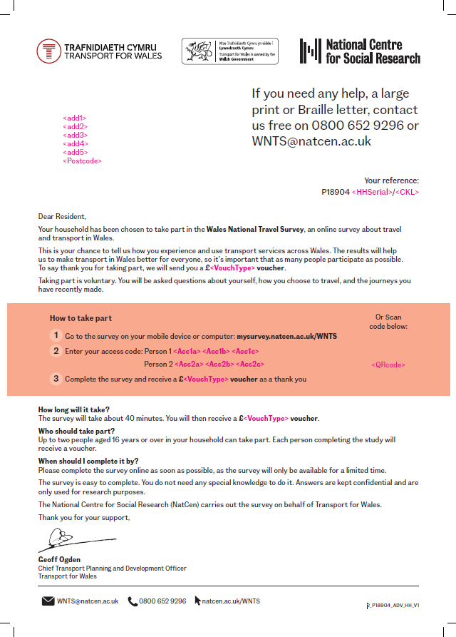
Appendix A

Appendix B
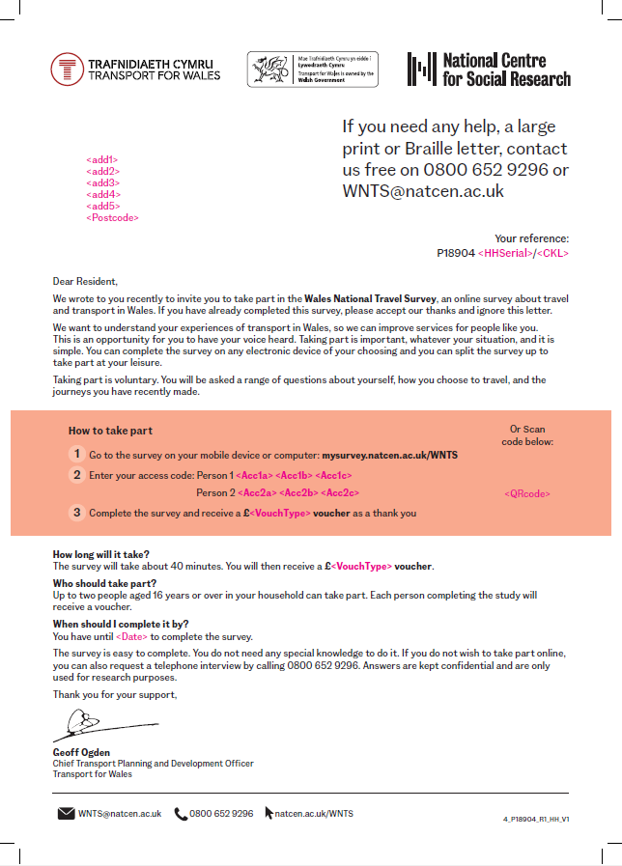

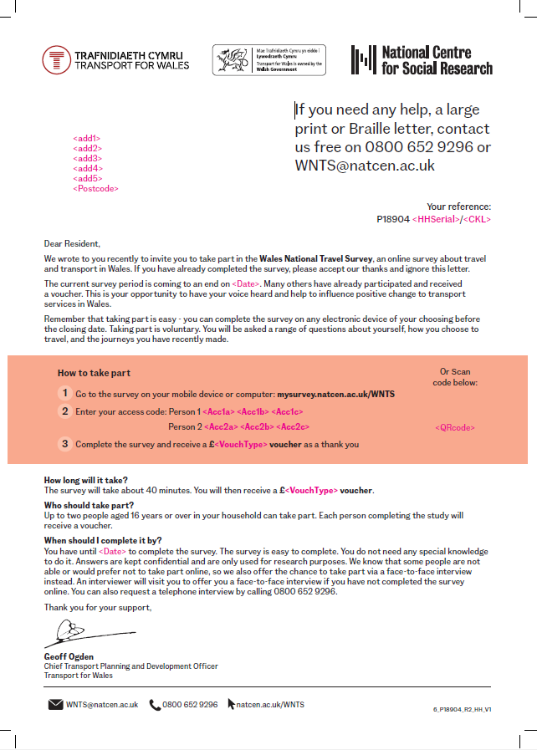
Appendix C

Appendix D


