Notice for operators
Concessionary Travel Card update
From the 9 September 2019 all bus pass holders across Wales will be able to apply for a new-style Transport for Wales branded Concessionary Travel Card. You’ll start to see an increased volume of new-style cards being presented for travel.

The new-style cards offer the same free travel rights as the current cards.
Both styles of Concessionary Travel Cards must be accepted, in line with the usual terms and conditions.
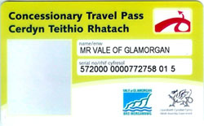

If a new-style card doesn’t work on your ticket machine, check the photo resembles the passenger and that the printed expiry date shows that the card is valid. If it does, please allow the passenger to travel. You’ll need to report any issues with your ticket machine on your return to the depot.
If any passengers, or their friends or family ask why they haven’t received a new-style card yet, please advise them that they can apply for one at www.tfw.wales/travelcards or call 0300 303 4240 for further information.
Current old-style cards are still valid until 31 December 2019 for travel and must be accepted.

